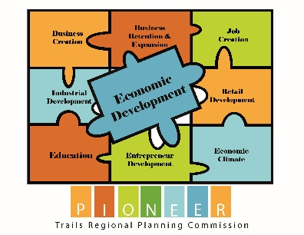
2026 Reporting Period Project Submission Form
(April 1, 2025 – March 31, 2026)
Who is providing Information?
Partner Agencies:
_________________________
_________________________
_________________________
_________________________

Name: ___________________________
Title: ____________________________
Company: ________________________
Address: _________________________
Email: ___________________________
Phone: __________________________

Project Name: ___________________________________

Project Description:

Start Date: ___/___/___ End Date: ___/___/___ Ongoing: □ Yes □ No

Project Goal and Objective (Please identify the GOAL from the 2024 5-year CEDS that best fits this project and its impact):
□ Encourage Entrepreneurship and Business Growth
□ Foster efficient business development, expansion, diversification, job growth, and entrepreneurial activity throughout the region
□ Plan for Regional Prosperity
□ Support initiatives that remove barriers to employment, including, but not limited to education, child care, housing and healthcare
□ Improve the overall capacity of the region to make long-term capital investment decisions
□ Promote and preserve the region's rich cultural and historic resources and support local festivals and special events for the educational, economic, and community benefits of residents and visitors
□ Ensure the future availability of a skilled and flexible workforce prepared to meet the needs of both existing and emerging industries and technologies

□ Promote Infrastructure Improvements
□ Expand the role of technology in the region's economy
□ Improve and expand major transportation infrastructure networks to provide a safe transportation system
□ Improve the public infrastructure of the region in order to support and sustain a viable economy and environment
□ Quality of Place
□ Improve and expand park and recreation facilities such as hiking and biking trails
□ Recognize the opportunity to sustain and grow local emergency preparedness planning

Funding Source/Type (select all that apply):
□ Private □ Public □ Other: ____________

Source of funding (select all that apply):
□ City □ County □ State □ Federal □ Other _________________________

Funding Amount:

Public $________________ Private $________________ Other $________________

Measurables (quantitative measures) *Example: jobs retained/created, items purchased, estimated equitable benefits*:

Were new jobs Created?
□ Yes Full-Time____ Part-Time:____ □ No □ Unknown

How many jobs retained?
□ Yes Full-Time____ Part-Time:____ □ No □ Unknown

Have jobs been lost?
□ Yes Full-Time____ Part-Time:____ □ No □ Unknown

Other quantitative measures:

Planned Accomplishments:

Barriers Encountered:

