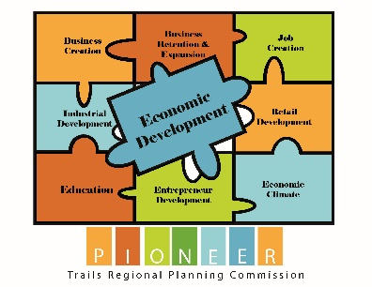
FY2024 Project Input Form
Who is providing Information?
Name: ___________________________
Title: ____________________________
Company: ________________________
Address: _________________________
Email: ___________________________
Phone: ___________________________

Project Name: ______________________________________________________

Project Description:

Start Date: ___/___/___ End Date: ___/___/___ Ongoing: □ Yes □ No

Project Goal (select one):
Please identify the GOAL from the 2022 5-year CEDS that best fits this project and its impact
□ Encourage entrepreneurship, business development and business expansion within the region
□ Plan for regional prosperity
□ Promote infrastructure improvements throughout the region
□ Preserve regional quality of place

Project Objective (select one objective with one sub category):
□ Encourage Entrepreneurship and Business Growth
□ Foster efficient business development, expansion, diversification, job growth, and entrepreneurial activity throughout the region
□ Quality of Place
□ Improve and expand park and recreation facilities such as hiking and biking trails
□ Recognize the opportunity to sustain and grow local emergency preparedness planning
□ Plan for Regional Prosperity
□ Support initiatives that remove barriers to employment, including, but not limited to education, child care, housing and healthcare
□ Improve the overall capacity of the region to make long-term capital investment decisions
□ Promote and preserve the region's rich cultural and historic resources and support local festivals and special events for the educational, economic, and community benefits of residents and visitors
□ Ensure the future availability of a skilled and flexible workforce prepared to meet the needs of both existing and emerging industries and technologies
□ Promote Infrastructure Improvements
□ Expand the role of technology in the region's economy
□ Improve and expand major transportation infrastructure networks to provide a safe transportation system
□ Improve the public infrastructure of the region in order to support and sustain a viable economy and environment

Funding Source/Type (select all that apply):
□ Private □ Public □ Other: ____________________________________________________

Source of funding (select all that apply):
□ City □ County □ State □ Federal □ Other _________________________

Funding Amount:

Public $________________ Private $________________ Other $________________

Measurables (quantitative measures) *Example: jobs retained/created, items purchased, estimated equitable benefits*:

Partner Agencies:
_________________________
_________________________
_________________________
_________________________

Were new jobs Created? If so, how many FT, and how many PT?

How many jobs retained?

Have jobs been lost? If so, how many PT, and FT?

Planned Accomplishments:

Barriers Encountered:

